7COM1079-0901-2025 - Team Research and Development Project

Final report title: Correlation between rating and Number of Votes of Japanese Anime

Group ID: B176

Dataset number: ds109

Prepared by: [ Dipak Solanki 22159999
Muhammad Ibrahim 24160228
Rony Selvin 24159913
Shashank katkam 24160094
Pawan kumar talapaneni 24160030 ]

University of Hertfordshire

Hatfield, 2025

Table of Contents

Introduction

Problem statement and research motivation

The data set

Research question

Null hypothesis and alternative hypothesis (H0/H1)

Background research

Research papers (at least 3 relevant to your topic / DS)

Why RQ is of interest (research gap and future directions according to the literature)

Visualisation

Appropriate plot for the RQ output of an R script (NOT a screenshot) and required supplementary graph/table

Useful information for the data understanding

Analysis

Statistical test used to test the hypotheses and output

The null hypothesis rejected /not rejected based on the p-value

Evaluation – group’s experience at 7COM1079

What went well

Points for improvement

Group’s time management

Project’s overall judgement

Comment on GitHub log output

Conclusions

Results explained.

Interpretation of the results

Reasons and/or implications for future work, limitations

Reference list

Harvard (author, date) format.

Appendices

R code used for analysis and visualisation.

GitHub log output.
- Introduction

1.1 Problem statement and research motivation (100 words)

Understanding how audience engagement affects movie ratings is a key focus in media and data-driven research. Metrics such as user ratings and total votes reflect audience opinions and popularity, but the relationship between them is not always straightforward. Determining whether greater audience participation is associated with higher ratings can help researchers, streaming services, and filmmakers better interpret viewer behaviour. Earlier research suggests that audience activity can strongly shape media evaluation trends (Liu, 2006). Therefore, this study investigates the relationship between IMDb user ratings and the number of votes to gain deeper insight into how popularity aligns with perceived quality.

1.2 The data set (75 words)

The dataset used in this study includes information on movies and series, featuring variables such as Title, Genre, User Rating, Number of Votes, Runtime, and Release Year. For this research, User Rating and Number of Votes are the key variables analysed to explore audience behaviour. The dataset provides sufficient variation and sample size to examine whether viewer engagement is associated with rating patterns effectively.

1.3 Research question (50 words). State your RQ (50 words)

This study investigates whether a meaningful relationship exists between User Rating and Number of Votes in the dataset. The purpose is to determine whether audience participation affects perceived quality. Thus, the guiding research question is: Is there a significant correlation between User Rating and Number of Votes?

1.4 Null hypothesis and alternative hypothesis (H0/H1) (100 words)

This study aims to determine if there is a meaningful relationship between user ratings and the number of votes. To do this, the null hypothesis (H0) states that there is no significant correlation between the two variables, meaning changes in vote count do not affect user ratings. On the other hand, the alternative hypothesis (H1) proposes that a significant correlation exists, suggesting that audience engagement may be connected to how viewers rate a movie or series. These hypotheses serve as the foundation for the statistical analysis in this research.

- Background research

2.1 Research papers (at least 3 relevant to your topic / DS) (200 words)

Several researchers have investigated how audience engagement and online rating systems reflect user preferences and perceptions of content quality. Liu (2006) explored the link between online word-of-mouth and product popularity, showing that greater engagement often corresponds to stronger audience reactions. Although his work focused on consumer products, the same principles apply to media ratings, where user votes function as digital word-of-mouth. Similarly, Dellarocas, Zhang, and Awad (2007) studied online movie reviews and found that user-generated feedback—such as ratings and vote counts—significantly shapes public opinion of films, emphasizing the impact of collective audience behavior on evaluation.

More closely related to this study, Otterbacher (2013) examined online reviewing platforms and found that increased participation is often linked to stronger or more consistent rating patterns. This indicates that the number of votes may reflect not only popularity but also the reliability of a rating.

While the specific dataset in this project has not been directly analyzed in prior research, these studies collectively underscore the value of examining how audience activity relates to rating outcomes in digital media contexts.

  - Why RQ is of interest (research gap and future directions according to the literature) (100 words)

The relationship between user ratings and audience voting behaviour remains an important topic in digital media research. Although previous studies have examined online engagement patterns, they often use different platforms or time periods, leaving a gap in understanding how these relationships appear in newer datasets. Exploring whether user ratings correlate with the number of votes provides insight into how popularity and perceived quality interact. This research contributes to existing literature and supports future work on audience behaviour, platform recommendation systems, and the evolving dynamics of online rating environments.

- Visualisation

3.1 Appropriate graphs for the RQ (50 words)

A scatter plot was selected as it best illustrates the relationship between user rating and number of votes. A histogram was included to show the distribution and skewness of vote counts. Both visualisations were produced using an R script and presented with clear English titles and appropriate axis labels.

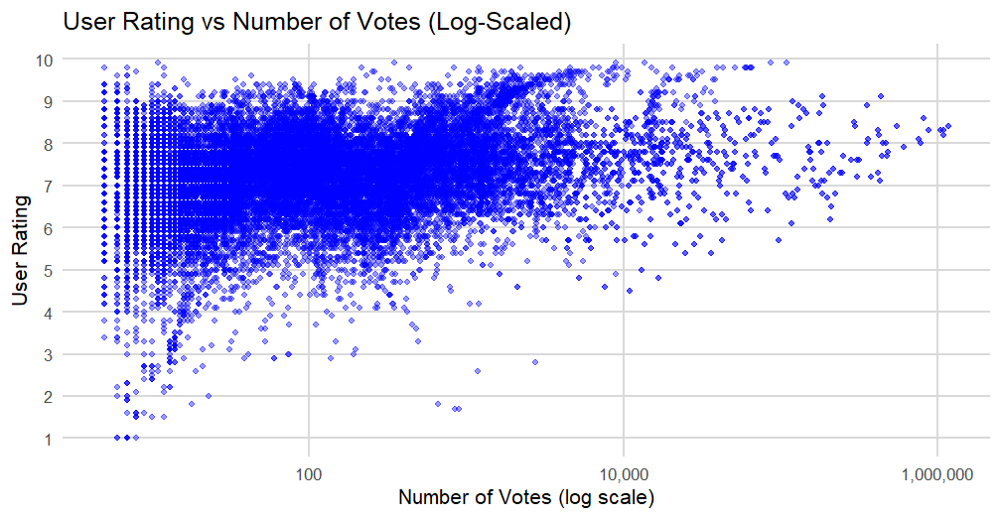

  - Additional information relating to understanding the data (optional) (50 words)

The histogram highlights the highly skewed distribution of vote counts, indicating that most titles receive relatively few votes while only a small number achieve extremely high engagement. This helps contextualise the scatter plot by showing why many data points cluster at lower vote levels, improving understanding of overall audience behaviour.
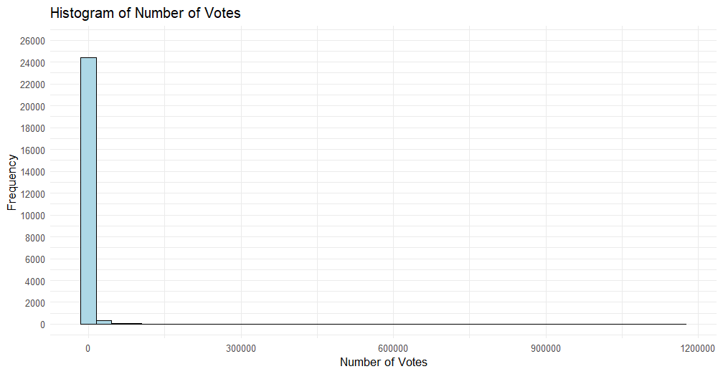

  - Useful information for the data understanding (50 words)

The visualisations show that titles with higher vote counts tend to cluster around mid-to-high user ratings, suggesting a potential relationship between popularity and perceived quality. The concentration of lower vote counts also indicates uneven audience engagement across the dataset, which is important when interpreting the overall correlation patterns.

- Analysis

  - Statistical test used to test the hypotheses and output (75 words)

Since both variables are continuous and appropriate for assessing a linear connection, a Pearson correlation test was utilized to investigate the link between user rating and vote total. Because the dataset offers numerical values without category classification, making it possible to quantify the correlation's strength and direction, this test was appropriate. The test yielded a correlation coefficient and p-value, which together support the assessment of the presented hypotheses and show whether the observed association is statistically significant.

  - The null hypothesis is rejected/not rejected based on the p-value (100 words)

Based on the p-value of 0.06049986 obtained from the Pearson correlation test, the null hypothesis is not rejected. This indicates that the relationship between User Rating and Number of Votes is not statistically significant at the 0.05 threshold. Although a slight positive association may be visible in the visualisations, the evidence is not strong enough to confirm a meaningful correlation within this dataset. Therefore, any apparent pattern should be interpreted with caution, as it may be influenced by sampling variation rather than a genuine statistical relationship.

- Evaluation – group’s experience at 7COM1079

  - What went well (75 words)

Despite limited participation from several group members, the two active participants collaborated effectively and maintained steady progress throughout the project. Communication between the contributing members was clear, allowing tasks to be divided efficiently and completed on time. Working together strengthened our understanding of data analysis in R and improved our ability to interpret statistical outputs. The consistent effort of engaged members ensured that the assignment's core requirements were successfully met, despite reduced overall group involvement.

  - Points for improvement (75 words)

A key improvement area is the uneven contribution within the group, as only two members actively participated in the project. Greater involvement from everyone would have balanced the workload and eased pressure on the contributing members. Setting clearer expectations early on and organising more frequent check-ins could strengthen accountability. With better coordination and earlier planning, each member would be able to contribute more effectively, resulting in a more balanced and collaborative group experience.

  - Group’s time management (50 words)

Time management was challenging due to limited participation from several members, which placed additional responsibility on the two active contributors. Despite this, the contributing members organised their tasks effectively and maintained a steady workflow. Regular communication and prioritising key deadlines helped ensure that the project was completed within the required timeframe.
  - Project’s overall judgement (50 words)

Overall, the project was successful in demonstrating our ability to conduct statistical analysis and interpret data using R. Although group participation was uneven, the work completed by the active members met the assignment’s academic requirements. The project provided valuable experience in collaboration, data cleaning, visualisation, and hypothesis testing.

  - Note any changes to group since original allocation if applicable. Add new or amended GitHub Ids for new members (75 words, write only if applies to your group arrangements)

  - Comment on the GitHub log output (50 words)

Appendix B has the GitHub log, which shows that contributions have been steady throughout the development process. Three milestones stand out as very important

Commit 1: Added data cleaning script – Cleaned data by fixing errors and formatting, improving accuracy for analysis tasks effectively.

Commit 2: Created visualisation plots in R - Produced R visualisations revealing patterns and guiding the choice of Pearson correlation analysis method.

Commit 3: Implemented statistical test and exported results - added the Pearson statistical test, providing the evidence required to evaluate the hypotheses effectively.

- Conclusions

  - Results explained (75 words)

The Pearson correlation test examined the relationship between User Rating and Number of Votes. The resulting p-value of 0.06049986 exceeded the 0.05 significance threshold, indicating that the null hypothesis could not be rejected. Although the scatter plot showed a slight upward trend, the evidence was insufficient to confirm a statistically meaningful correlation. This suggests that variations in user ratings cannot be reliably explained by differences in vote counts within this dataset.

  - Interpretation of the results (75 words)

The results indicate that the relationship between User Rating and Number of Votes is not statistically significant, meaning the RQ is not supported by the data. This suggests that popularity, measured through vote counts, does not reliably influence or predict user ratings within this dataset. For the wider population, the findings imply that audience engagement varies independently of perceived quality. In a broader context, rating platforms should therefore avoid assuming that highly rated titles are also the most widely voted.

  - Reasons and/or implications for future work, limitations of your study (50 words)

Future research could explore more variables, such as genre or release year, to gain a deeper understanding of what influences ratings. This study is limited by using a single dataset and by the uneven distribution of vote counts. Using larger datasets or conducting a longitudinal analysis may offer stronger insights into audience engagement and rating patterns.

- Reference list (not included in the word count)

Dellarocas, C., Zhang, X., and Awad, N. (2007)
Exploring the value of online product ratings in revenue forecasting: The case of motion pictures. Journal of Interactive Marketing, 21(4), pp.23–45.

Liu, Y. (2006)
Word of mouth for movies: Its dynamics and impact on box office revenue. Journal of Marketing, 70(3), pp.74–89.

Otterbacher, J. (2013)
Popularity signals in online reviews: Sentiment, helpfulness, and reputation. Journal of the American Society for Information Science and Technology, 64(5), pp.952–965.

- Appendices

A R code used for analysis and visualisation (not included in the word count) Analysis.R code with the appropriate statistics to test the hypotheses.

library(ggplot2)
library(scales)
data <- read.csv("imdb_anime.csv") # Replace with your real CSV filename
data$Number.of.Votes <- as.numeric(gsub(",", "", data$Number.of.Votes))
data$User.Rating <- as.numeric(data$User.Rating)
data_clean <- data[!is.na(data$User.Rating) & !is.na(data$Number.of.Votes), ]

#build a scatter plot
ggplot(data_clean, aes(x = Number.of.Votes, y = User.Rating)) +
geom_point(color = "blue", alpha = 0.4, size = 1.5) +
scale_x_log10(labels = comma_format()) +
scale_y_continuous(breaks = seq(1, 10, 1)) +
labs(
title = "User Rating vs Number of Votes (Log-Scaled)",
x = "Number of Votes (log scale)",
y = "User Rating"
) +
theme_minimal(base_size = 14) +
theme(
panel.grid.major = element_line(color = "grey85"),
panel.grid.minor = element_blank()
)

# Build histogram object to compute counts
p <- ggplot(data_clean, aes(x = Number.of.Votes)) +
geom_histogram(bins = 40)

gb <- ggplot_build(p)
max_count <- max(gb$data[[1]]$count, na.rm = TRUE)
Round max frequency to next 2000 multiple
upper_lim <- ceiling((max_count + 1) / 2000) * 2000

ggplot(data_clean, aes(x = Number.of.Votes)) +
geom_histogram(bins = 40, fill = "lightblue", color = "black") +
labs(
title = "Histogram of Number of Votes",
x = "Number of Votes",
y = "Frequency"
) +
scale_y_continuous(limits = c(0, upper_lim),
breaks = seq(0, upper_lim, by = 2000)) +
theme_minimal()

# Statistical test used to test the hypotheses and output

data$Number.of.Votes <- as.numeric(gsub(",", "", data$Number.of.Votes))
data$Number.of.Votes <- as.numeric(gsub(",", "", data$Number.of.Votes))
data$User.Rating <- as.numeric(data$User.Rating)
data_clean <- data[!is.na(data$User.Rating) & !is.na(data$Number.of.Votes), ]
correlation_test <- cor.test(data_clean$User.Rating,
data_clean$Number.of.Votes,
method = "pearson")
correlation_test

B.

ac6ef5cd27a982a97d6472ae0e2c68e9735b5d0f | 2025-12-011 | Data cleaning | Dipak14102004

0f372134ec7505736897c5f290e3709834c165f8 | 2025-12-11 | Visualisation | Dipak14102004

c62db33e0a839307b10747a5dba3873dce688ade | 2025-12-11 | Analysis | Dipak14102004

